SYED SUALEH ABBAS 10303

SYED MOHSIN NAQVI

SYED ZAID NAQVI

Lab 6: Design and FPGA Implementation of the ALU for a Single-Cycle RISC-V Processor

Task 1: ALU Block Diagram Design

Block diagram of the ALU.

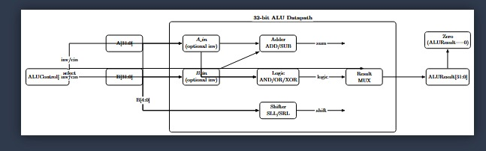

Task 2: Verilog Description and Testbench Development

Verilog source file for ALU

`timescale 1ns / 1ps

//////////////////////////////////////////////////////////////////////////////////

// Company:

// Engineer:

//

// Create Date: 02/17/2026

// Design Name: 32-bit ALU

// Module Name: ALU32bit

// Description: Self-contained 32-bit ALU with multiple operations

//////////////////////////////////////////////////////////////////////////////////

module ALU32bit(

input [31:0] A, // First operand

input [31:0] B, // Second operand

input [3:0] ALUControl, // Control signals to select operation

output reg [31:0] ALUResult, // Result of ALU

output Zero // Zero flag

);

// Internal wires

wire [31:0] A_in, B_in;

wire [31:0] and_out, or_out, xor_out, nor_out, sll_out, srl_out, sum, slt_out;

wire [31:0] carry;

// Invert inputs if needed (for SUB or NOR)

assign A_in = (ALUControl[3]) ? ~A : A;

assign B_in = (ALUControl[2]) ? ~B : B;

// Logic operations

assign and_out = A_in & B_in;

assign or_out = A_in | B_in;

assign xor_out = A_in ^ B_in;

assign nor_out = ~(A_in | B_in);

// Shift operations

assign sll_out = A << B[4:0]; // Logical left shift

assign srl_out = A >> B[4:0]; // Logical right shift

// Ripple carry adder for ADD/SUB

assign sum[0] = A_in[0] ^ B_in[0] ^ ALUControl[2]; // cin = 1 for subtraction

assign carry[0] = (A_in[0] & B_in[0]) | (B_in[0] & ALUControl[2]) | (A_in[0] & ALUControl[2]);

genvar i;

generate

for (i = 1; i < 32; i = i + 1) begin : adder

assign sum[i] = A_in[i] ^ B_in[i] ^ carry[i-1];

assign carry[i] = (A_in[i] & B_in[i]) | (B_in[i] & carry[i-1]) | (A_in[i] & carry[i-1]);

end

endgenerate

// SLT (Set on Less) - only LSB = 1 if A < B

assign slt_out = 32'b0 | (sum[31] ? 32'b1 : 32'b0);

// Output multiplexer based on ALUControl

always @(*) begin

case(ALUControl)

4'b0000: ALUResult = and_out; // AND

4'b0001: ALUResult = or_out; // OR

4'b0010: ALUResult = sum; // ADD

4'b0110: ALUResult = sum; // SUB

4'b0011: ALUResult = xor_out; // XOR

4'b1100: ALUResult = nor_out; // NOR

4'b0111: ALUResult = slt_out; // SLT

4'b0100: ALUResult = sll_out; // SLL

4'b0101: ALUResult = srl_out; // SRL

default: ALUResult = 32'b0;

endcase

end

// Zero flag

assign Zero = (ALUResult == 32'b0);

endmodule

Testbench file

`timescale 1ns / 1ps

//////////////////////////////////////////////////////////////////////////////////

// Testbench for ALU32bit

//////////////////////////////////////////////////////////////////////////////////

module ALU32bit_tb;

// Inputs

reg [31:0] A;

reg [31:0] B;

reg [3:0] ALUControl;

// Outputs

wire [31:0] ALUResult;

wire Zero;

// Instantiate the ALU

ALU32bit uut (

.A(A),

.B(B),

.ALUControl(ALUControl),

.ALUResult(ALUResult),

.Zero(Zero)

);

initial begin

// Initialize inputs

A = 32'd15;

B = 32'd10;

// Test AND

ALUControl = 4'b0000; // AND

#10;

// Test OR

ALUControl = 4'b0001; // OR

#10;

// Test ADD

ALUControl = 4'b0010; // ADD

#10;

// Test SUB

ALUControl = 4'b0110; // SUB

#10;

// Test XOR

ALUControl = 4'b0011; // XOR

#10;

// Test NOR

ALUControl = 4'b1100; // NOR

#10;

// Test SLT (A < B)

A = 32'd5;

B = 32'd10;

ALUControl = 4'b0111; // SLT

#10;

// Test SLT (A > B)

A = 32'd20;

B = 32'd10;

ALUControl = 4'b0111; // SLT

#10;

// Test SLL (shift left)

A = 32'h0000_000F; // 15

B = 32'd2; // shift by 2

ALUControl = 4'b0100; // SLL

#10;

// Test SRL (shift right)

A = 32'h0000_00F0; // 240

B = 32'd4; // shift by 4

ALUControl = 4'b0101; // SRL

#10;

// Test Zero flag

A = 32'd5;

B = 32'd5;

ALUControl = 4'b0110; // SUB → 0

#10;

$finish;

end

endmodule

Simulation waveforms showing correct operation

and
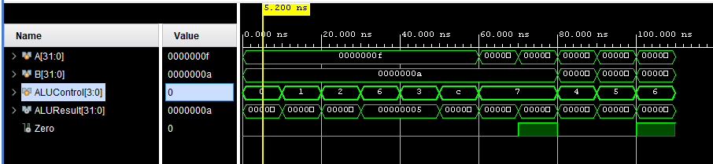

OR
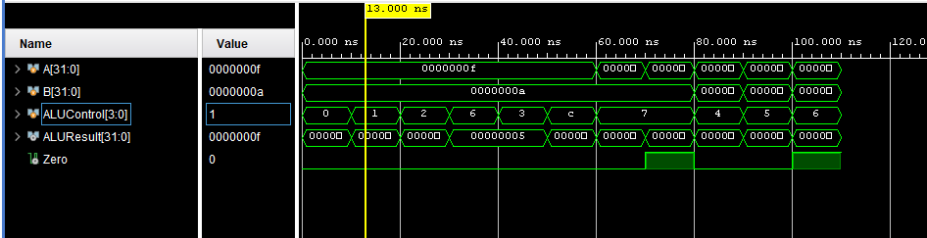

ADD
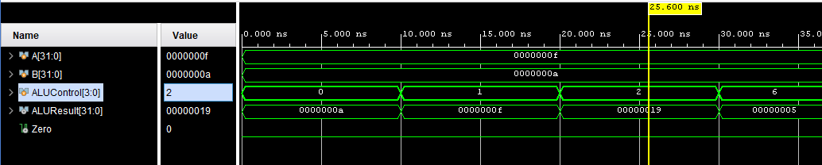

SUB

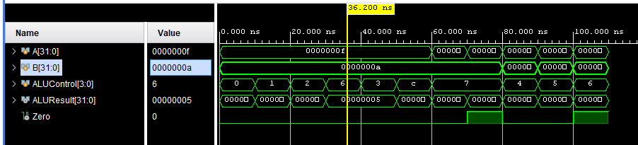

XOR

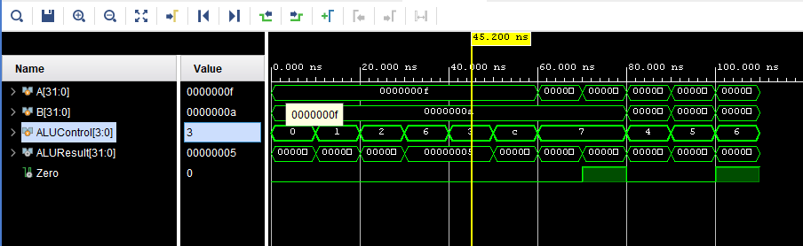

NOR
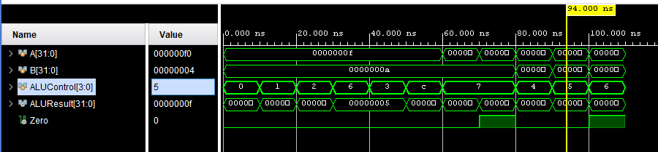

SLT
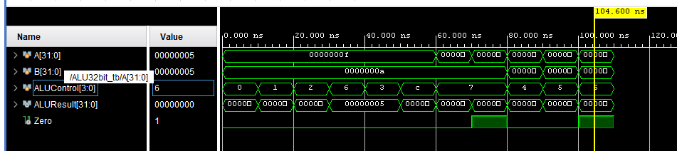

SLL
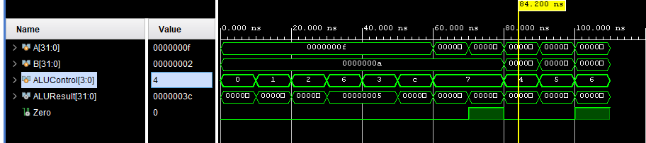

SRL

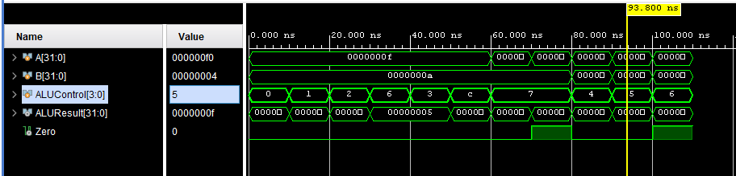

Truth table of test bench:
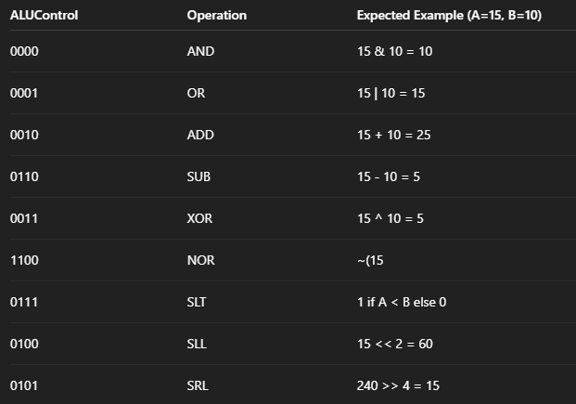

Task 3: FPGA Synthesis and RTL Analysis

RTL schematic screenshots

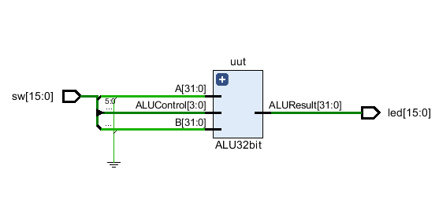

Demonstration of FPGA operation

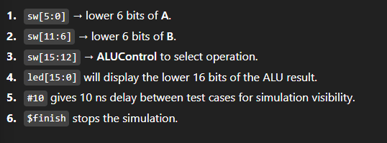

FPGA PICTURES:

AND:

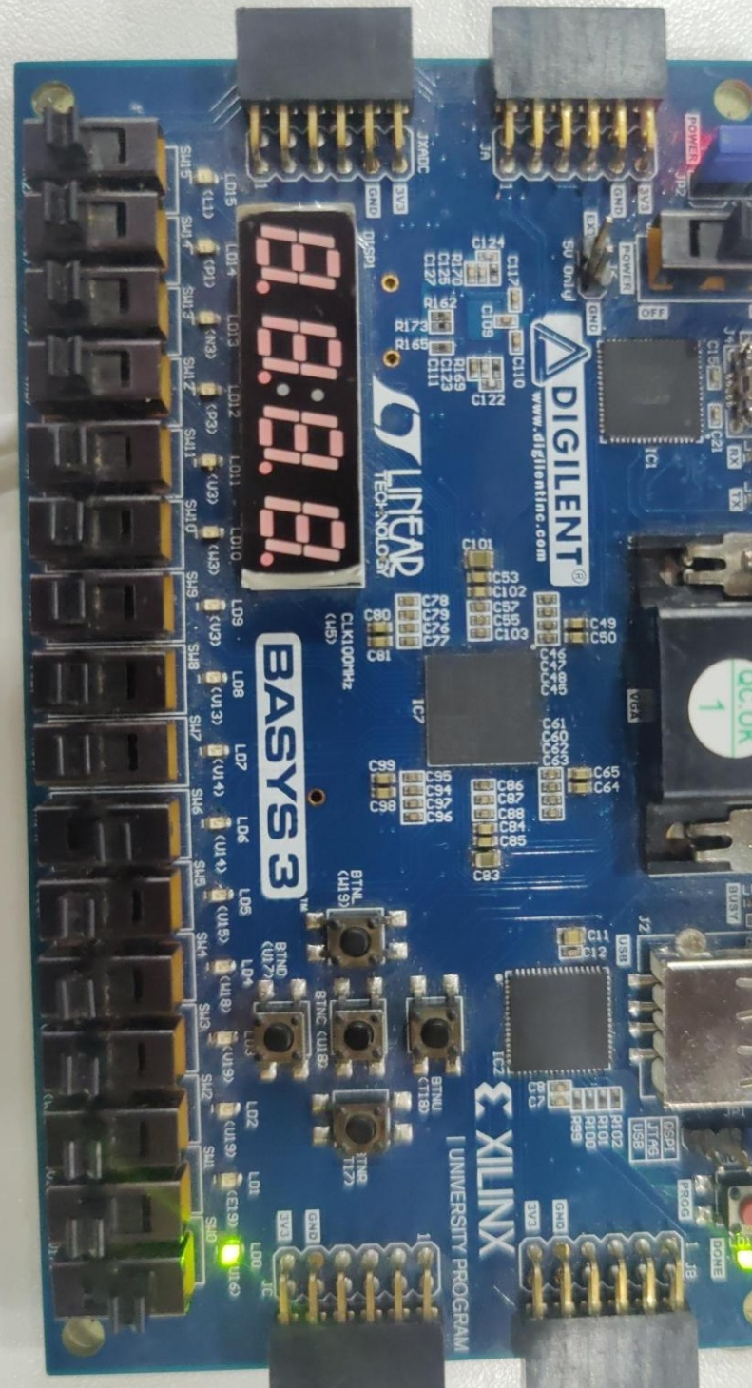

ADD:

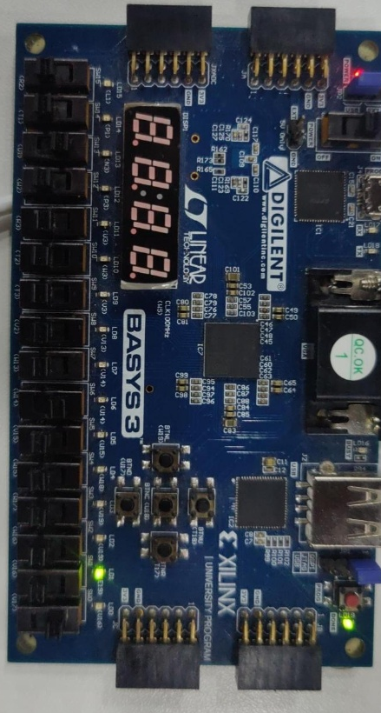

OR:

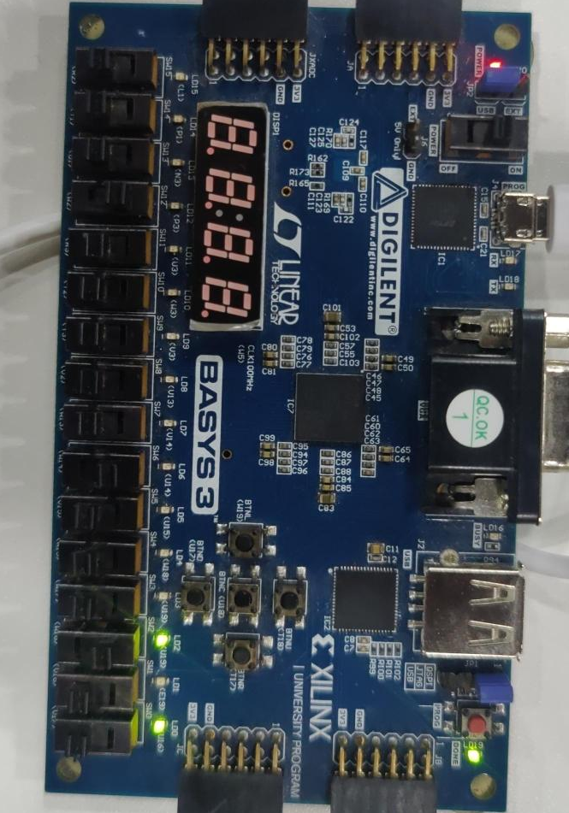

XOR:

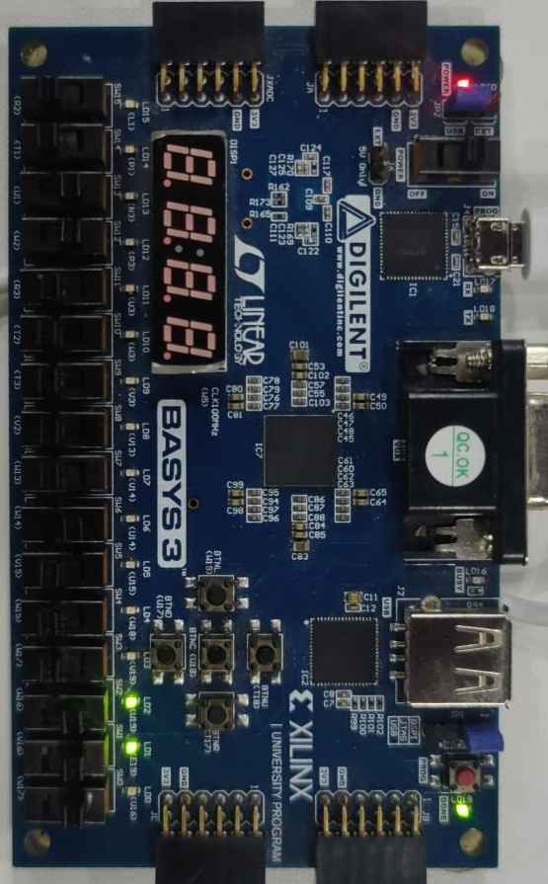

SUB:

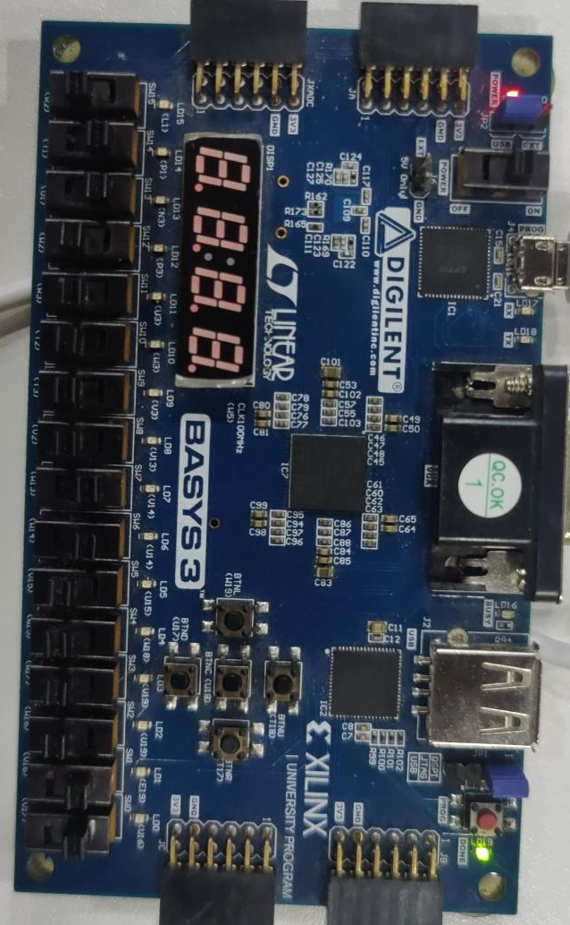

Assessment Rubric
Lab 6: Design and FPGA Implementation of the ALU for a Single-Cycle RISC-V Processor

Name: | Student ID: | Section:

Points Distribution

 | Task No. | LR 2 (Code) | LR 5 (Results) | LR 11  (Design)
In-Lab | Task 1 | - | - | /20
In-Lab | Task 2 | /20 | /15 | -
In-Lab | Task 3 | /10 | /15 | -
Total Points |  | /30 | /30 | /20
CLO Mapped |  | CLO 1

Affective Domain Rubric |  | Points | CLO Mapped
AR7 | Report Submission & Git Upload | /10 & /10 | CLO 1

CLO | Total Points | Points Obtained
1 | 100
Total | 100

For description of different levels of the mapped rubrics, please refer to the Lab Evaluation Assessment Rubrics and Affective Domain Assessment Rubrics provided here.

